PRODUCT |  | PREDNISOLONE |  | DATE OF SAMPLING | MAR.20.2026
BATCH NUMBER |  | L0008 |  | DATE OF REPORT | APR.13.2026
BATCH SIZE |  | 100 KG |  | MANUFACTURING DATE: MAR.20.2026  RETEST DATE: MAR.19.2031
CRITERIA: USP2025
NAME OF THE TEST  (METHODE) |  | SPECIFICATON |  | RESULTS
APPERANCE |  | WHITE OR PRACTICALLY WHITE, ODORLESS, CRYSTALLINE POWDER |  | WHITE CRYSTALLINE POWDER
SOLUBILITY (ANNUAL) |  | SOLUBLE IN METHANOL AND IN DIOXANE, SPARINGLY SOLUBLE IN ACETONE AND IN ALCOHOL, SLIGHTLY SOLUBLE IN CHLOROFORM, VERY SLIGHTLY IN WATER. |  | CONFORM
IDENTIFICATION | A.IR | MEETS THE REQUIREMENT |  | CONFORM
IDENTIFICATION | B.UV | MEETS THE REQUIREMENT |  | CONFORM
SPECIFIC ROTATION |  | +97° ~ +103° |  | +98.0°
LOSS ON DRYING |  | ≤1.0% |  | 0.15%
RESIDUE ON IGNITION |  | NEGLIGIBLE |  | NEGLIGIBLE
SELENIUM |  | ≤0.003% |  | CONFORM
CHROMATOGRAPHIC PURITY |  | ANY PEAK ≤1.0%  ONLY ONE PEAK >0.50%  TOTAL ≤2.0% |  | 0.42%  CONFORM  0.88%
ASSAY |  | 97.0 ~ 102.0%  ( DRIED BASIS) |  | 98.6%
RESIDUAL SOLVENTS |  |  | METHANOL ≤700PPM  METHYLENE CHLORIDE ≤600PPM  ACETIC ACID ≤5000PPM | 525 PPM  3PPM  LESS THAN LOQ(100.3 PPM)
MICRONIZED
STORAGE: STORE IN AN AIRTIGHT CONTAINER PROTECTED FROM LIGHT
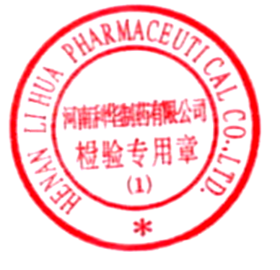
HENAN LIHUA PHARMACEUTICAL CO., LTD
CERTIFICATE OF ANALYSIS

